**Table of Contents**

1. I**ntroduction**
   1. **Early age of hotel management system in Nepal.**
      1. **Problems faced in early age.**
   2. **Research questions.**
   3. **Hypothesis**
   4. **Key features**
   5. **Need for the study**
   6. **Objectives**
   7. **Gaps in ICTs hotel and hospitality industry**
2. **Background**
   1. **Factors involving with use of IT in hotel Industry**
   2. **Problems in current scenario.**
      1. **Existing problems**
      2. **Achievement over the problems.**
   3. **Requirement for implementation of the IT in Industry**
   4. **Use of IT in Hotel Industry.**
      1. **Problem with installment of IT.**
      2. **Solution methods for the problem.**
3. **Literature Review**
   1. **Growth in Hotel and restaurant business**
   2. **Technology and economic growth**
   3. **Hospitality industry and information technology.**
4. **Methodology**
   1. **Components of study**
5. **Solution method** 
   1. **Problems and solutions.**
6. **Conclusion**
7. **References.**

**Introduction**

The service industry is one of the most important industries. Restaurants has become the one of the biggest components of the service industry. Without any doubt, restaurants business are the one of the most important sector of any country, huge portion of country revenue are generated from this particular sector. Likewise, Restaurants have become an integral part of the daily life of average Nepali salaried class. Rather than staying at home and cooking. People are spending that extra time and money to try new thing in a city which has been getting high standards new restaurant opened with so high frequency in recent times. The constantly changing food habits of a city population “Restaurants in Nepal have changed a lot over a years.

**Present scenario**

If we talk about the urban areas, there is a large of numbers of restaurants where large number of people love to go there to taste different types of food. Rather than other industry, restaurant has become have become the major party of source of income. In context of Kathmandu places like thamel, durbarmarg have the highest numbers of restaurants which people love to go where the serving people are done through the waiters. Likewise, the serving of a food as per customers order are also served through the waiters.

**Problems encountered**

Restaurants opened with high frequency in recent times causing lots of problems in a restaurants like the numbers of customers are facing the problem of disordering and disserving of the food by the waiters. Likewise in some restaurants, arrival time of customers is more than the serving time of the waiters where the people have to wait lots of time to be served by the waiters. As there is no digital ordering system which may create crowd in the environment by the customer which disturb other customer while calling to serve them. As the payment system is paper based, it also create problem in a payment system.

**Research Questions**

The following research questions are proposed in this study:

1. What are the main drivers for restaurant’s IT efforts?

2. What is the top challenge facing restaurants technology departments?

**Background**

As the restaurants industry increased which helps to boosts the development of the country in the faster way but also in same manner, the restaurants and the customers are facing lots of problems. The customers are not satisfied with service provided by the restaurants. The service provided by the restaurant is so primitive which leads the customers to wait for the longer time as the expected to get served. Due to the human based service it create crowd in the environment and the customer have to call the waiter time to time to get served and also to do payment. Due to this type of problem, the high chance of decreasing of the customers in the restaurants. The restaurants industry can be better services, facilities to the customers, guests using the IT and IT related tools in them. Use of information technology makes the tasks easier, faster, reliable, and cheaper in the restaurant network.

**The constraint for the installment of IT in Restaurants**

* POOR (OR NONEXISTENT) NETWORK SECURITY
* LACK OF PROFESSIONAL OR QUALIFIED EXPERIENCE
* THE DOWNFALL OF OLD TECHNOLOGY
* NO DATA BACKUP / BACKUP ISSUESHARDWARE OR SOFTWARE ISSUES

#### TOO MANY EMPLOYEES HAVE ACCESS TO DATA AND INFORMATION

#### LACKING AN IT PLAN

**The requirements for implementation in the restaurant system in Nepal**

* Skilled Manpower
* Technical customer
* Internet availability
* Existing non IT service methods are to be replaced by IT tools.
* Budget problem

The skilled manpower needs to be there for the IT implementation in any sector. A person should be known to the technology and the devices. The model of the IT tools that is provided in certain department should be known to the customer and the user can access to it to have service by them.

Technical customer refers to the customers that are already known to the IT and the use of IT tools.

The provision of Internet is to be everywhere around the area of services.

**Goals to achieve in Restaurant**

* Faster services
* Customer care help option
* AI based or technology based services
* Digital services and payment
* Active interaction between service provider and customer

**Literature Review**

Xinhua news agency reported on Saturday, the Naulo Restaurant uses five robots for their service to the customers which was developed by Paaila Technology, a Nepali company, specializing in robotics and artificial intelligence (AI) technology. It is also the latest approach for the digitalizing the food serving method in the valley. They are user friendly and easy to access.

**Growth in Hotel and restaurants business: A Brief Empirical Analysis**

Since, Nepal is land of different historical and mountaineering hub, many tourists inside the country as well as outside the country intends to visit those places, some aim to climb the mountains of Nepal once in their life time. Well, that definitely increases the number of tourist and creates huge opportunities for business to local people. Hotel and restaurant business is one of them. As, the flow of tourists has increased we can clearly see that the number of hotels and restaurant around those historical and mountains ranges places has increased day by day.

The industry that we know today began to take form in the early 1950s, leading the way for growth into the dynamic industry. Actual development of hospitality and tourism industry in Nepal started after 104 years‟ autocracy of Rana regime ended in 1950 and Nepal being officially open for tourism from 1951. 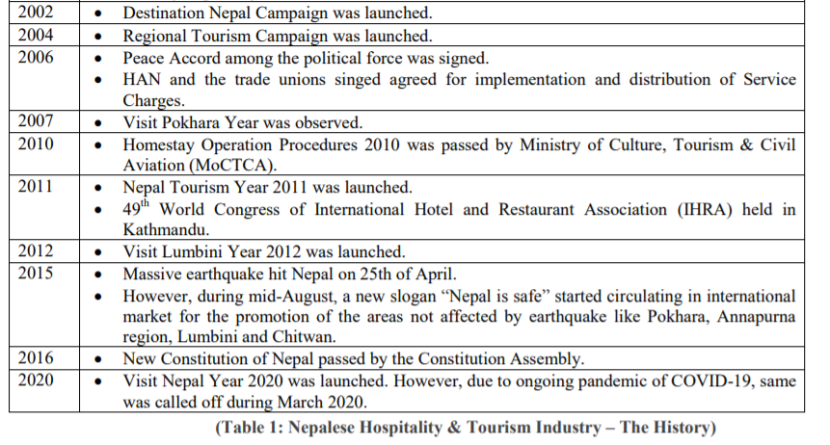 Also, the data that show the number of tourist that have visited Nepal throughout a year are listed below,

A tabular representation of arrival of tourist for the year 2011-2018 has been tabulated below:

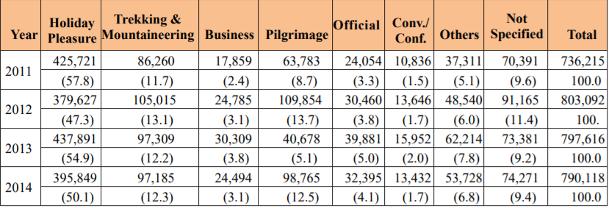

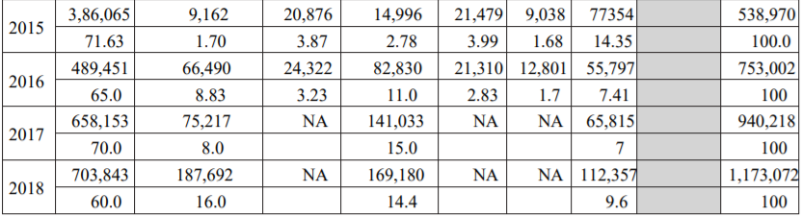

As the above data show that there is gradually increase in the number of tourist visiting in yearly. When more and more hotel and restaurant started to practice online and become modern, more number of tourist has come to Nepal, which really shows that proper feasibility of the certain things like online booking, online canceling, paying online, investigating hotel online has made the tourist more ease and they are interested in these kind of facility rather than those traditional way of booking and all other stuff. But still for the local tourist this data are not similar they are still practicing the traditional way of hotel booking, they are skeptical about the online way of doing business not only hotel/restaurant business, for every business. You see, Nepal doesn’t have that huge amount of the user or say market; it really needs that kind of market if it has to do some revolution in hotel business through technology. There are more challenges and obstacle where can be solved out by some solution which are listed in the solution model section.

**Technology and economic growth: a brief empirical analysis**

Technology has given huge aid in rapid development of any nations, without it development would not have been the same as it is now, development might have taken a way more time, As we can see in many developed countries where technology are modern and advance like china, japan, USA, Russia and many other developed country. Definitely there is direct relationship between development and technology. In context of Nepal, technology has been immersing rapidly, many other developed countries has been providing and helping with modern tools and equipment to this nation, which has definitely created impact in the development process of the nation. Well, in case of hotel and restaurant, modern devices and technology has been adopted by this country while doing business, which has result in the better services, polices, production rate and in time.

Technology is something to resist. Whether it foments antisocial behavior, cultural polarization, or wide-scale labor disruptions, technological change is a frustrating and perennial struggle facing society. The benefits largely accrue to a few oligarchs. More existentially, digital technologies rob us of our humanity, as automation and machine learning becomes a dangerous master we must serve.

At least, that’s the woeful impression you may get from some critics. Given this bleak view of affairs, it’s a wonder that anyone tolerates modern technology at all. Why allow such traumatic social shifts if nothing worthwhile comes of it? It is true that antipathy to technological change animates many proposals for limitations or outright bans on certain applications of technology. Yet apart from a few odd countries, no governments prohibit technological innovation altogether. Why? The truth is that many people realize that technological innovation, economic growth, and overall human wellbeing are intricately linked and that stemming our innovative capacity means handicapping our potential to progress. If we don’t allow some disruption today, then our overall quality of life will be much lower tomorrow. Economists have tried to better understand the relationship between innovation and growth for decades. A new paper by Mercatus scholars James Broughel and Adam Thierer assembles the literature on growth theory and accounting to paint a picture of just how important technology is to long-term growth.

**Hospitality Industry and Information Technology: A brief empirical analysis**

“Atithi Devo Bhava,” which literally translates to guest is god, is a popular expression in Nepal. In a country like Nepal where tourism is the major source of income, the hospitality industry has been booming at large. The total number of tourists coming to Nepal has been increasing every year. In 2018, the international tourists coming to Nepal was recorded at about 1.1 million, which is a 24% increase over 2017. Their purpose of visit also differs from trekking in the Himalayas to coming for a pilgrimage. As the hospitality industry mostly revolves around hotels, restaurants and some travel companies, Nepal is not lagging behind in the numbers of institutions providing hospitality service. But most top-class industries are distributed in Kathmandu, Pokhara and Chitwan only. Other highly potential destinations lack good hotels mainly due to the unavailability of road networks, proper infrastructure and transportation facilities. The government of Nepal is gradually working to provide equal opportunities to all the parts including the rural ones by properly maintaining and the upgrading the infrastructure.

When it comes to hospitality in Nepal, it is not only limited to hotels and restaurants. People have also started the concept of homestay. Homestays are a popular form of hospitality where visitors stay in a residence with the locals of the place where they are travelling. The homestay option offers several benefits like exposure to the local culture, traditions and opportunity to get to know the destination through the eyes of the locals. It certainly isn’t luxurious and may not be as comfortable as other types of lodging but it is a unique way to familiarize you with a new place. There are also other hospitality trends in Nepal like OYO rooms and Airbnb, which use modern amenities to provide hospitality service. If you prefer an affluent setting when coming to Nepal, there are numerous standard deluxe hotels such as Soaltee Crown Plaza, The Dwarika’s Hotel, Hotel Del’Annapurna, Hyatt Regency Kathmandu, Hotel Malla, Marriott Kathmandu Hotel, KGH Group of Hotels, Jagatpur Lodge and many others.

The hospitality industry is growing fast in Nepal and needs good employees who are passionate about providing great service. While there is certain niche skills required in this sector, there are a few universally vital qualities one should have to succeed in the field of hospitality. As hospitality is all about customer satisfaction, you should make sure that they are content with the service they are receiving. You should be able to create a welcoming environment and radiate positive energy even in stressful situations. Coming up with creative solutions when problems arise really helps to earn the trust of customers. For instance, a chef might have to change the usual process of preparing food for a lactose-intolerant customer. Teamwork is also crucial for the hospitality industry as working in a team allows helping each other in busy hours so that no customer is left behind. In the same way, as you should cooperate with customers, you should do the same with your team to prosper in this sector. When asked what she thinks is the most necessary factor to land a good job in the hospitality sector, Sales Executive at Hotel Del’Annapurna Ms. Aastha Manandhar responded: “I think passion and aspiration are key factors if one wants to thrive in the hospitality industry. Of course, a good education is also required but without desire and passion nothing can be achieved.”

**Methodology**

In the research process, the identification of the problem and the analysis of the possible solution method were identified through different methods including national and international websites, online blogs, newspapers, articles etc.

The research on the current conditions of the reputed hotels and restaurants including Hotel Himalaya Horizon, Hotel Annapurna and other nearby cafeteria are done. The problems are different before and after COVID crisis. The industry is facing more crisis after COVID.

The solution methods are gathered from the different resources and analysis of simulated hotels among our team members and solution methods are found out.

The components of the study are:-

* Literature review of the projects related to hotels in Nepal from government, private, and international agencies.
* Review of the Restaurant Entrepreneurs’ views on the blogs and articles.
* Reviews of the interviews of the related personnel.
* Analysis of by nearby cafes and restaurants near Baneshwor and Jawalakhel.

**Solution Model**

**Waiterless –Restaurant System**

In the era of digitization, all small and big industries are moving towards automation. Every industry, today, is seeking methods and technology through which they can work efficiently with very less number of men power. As computers are reliable, efficient and come under the categories of one time investment the industries are adopting them right into their core processes. The project ‘Waiter less Restaurant System’ introduces a restaurant which has a very minimal staff, a restaurant in which customer’s orders could reach the kitchen without the aid of waiter.

Implementation steps of the system

1. A server where all the data will be stored and all other devices will communicate with each other through their server.
2. A computer for manager to manage all the processing of the restaurant.
3. Devices on table, these will be used by the customer, to place their order.
4. A device which will be used to flash orders in the kitchen and to take input signal when the order is done.

**Network Security and Data back-up**

Network security is considered one the most critical parts of keeping your business safe, along with avoiding common IT problems that little or no network security could bring. To keep data and system safe, not to let the data being leaked, network security is must. An experienced and knowledgeable managed IT services provider can efficiently assist and monitor email and web hosting, data storage, server, and network maintenance, and much more. A managed IT services professional monitors and works on the most complicated IT issues. A data backup plan is something every business should have in place, no matter the size of the company. Failing to back-up data can actually be correlated with costing business money. Thus, the team can manage the storage and renew or erasable data for certain time.

The permission to access the application or the system within the network should only be provided to the specified people. The every user should be supervised by the IT department so that the leak or misuse of data of the system is controlled and security is maintained.

**Renew of Hardware and software**

The technology devices have a lifespan, no matter how advanced they are. Out-of-date systems are harder and slower to handle. The best way to resolve a common IT problem, such as old technology, is the implementation of new technology as well as the fast installation of this technology. Thus, in case of longer execution of the devices or software, they need some update or replacements.

An IT plan and a managed IT services team are important for better services. It needs greater plan and strategy for smooth performance of IT in the Organization or department. Managed IT services significantly benefits the system and department. Managed IT services saves the employees’ time, saves business money, monitors for a safer network, brings subject matter experts, and even gives access to more customizable services.

Top of Form

Bottom of Form

**References**

* Deltatechnepal.com
* <https://www.aliceplatform.com>
* <https://www.worlddata.info/asia/nepal/tourism>
* <http://www.aebjournal.org/>
* <https://careratingsnepal.com/>
* <https://www.coursehero.com/>
* <https://hmhub.me/>
* [https:///www.ais-now.comblog](https://www.ais-now.comblog)
* KMC journal, Govinda Bahadur Karki, MPhil, providing research article on tourism and hotel industries and their Impact on Nepalese base structure.
* Andrea Sullivan, providing the information on how the technology helps in economic growth.
* Dibesh Manandhar, providing information about hospitality sector in Nepal

[24th Feb 2020]